Tutshill Combined Design and technology, and Art and design scheme
Long term plan

This EYFS: Reception, Key stage 1 and Key stage 2 plan is designed to alternate between teaching Design and technology and Art and Design each half term

long-term plan: A&D and D&T - Overview (Reception -Year 3)

.

 | Autumn term |  | Spring term |  | Summer term |  | Stand- alone lessons
 | Design and technology | Art and design | Design and technology | Art and design | Design and technology | Art and design
EYFS:  Reception | Structures: Junk modelling  (6 lessons) | Drawing: Marvellous marks (6 lessons) | Textiles: Bookmarks (6 lessons) | Painting and mixed media: Paint my world  (6 lessons) | Structures: Boats (6 lessons) | Sculpture and 3D: Creation station (6 lessons) | Design and technology  Unit: Seasonal projects - as and when relevant throughout the year.  Art and design  Seasonal Crafts as and when relevant throughout the year.
Year 1 | Structures: Constructing a windmill  (4 lessons) | Drawing: Make your mark  (5 lessons) | Textiles: Puppets (4 lessons) | Sculpture and 3D:  Paper play (5 lessons) | Cooking and nutrition:  smoothies (6 lessons) | Painting and mixed media: Colour splash  (5 lessons)
Year 2 | Art and design | Design and technology | Art and design | Design and technology | Art and design | Design and technology
 | Sculpture and 3D:  Clay houses (5 lessons) | Structures: Baby bear's chair  (4 lessons) | Drawing: Tell a story  (5 lessons) | Mechanisms: Making a moving monster  (4 lessons) | Craft and design:  Map it out (5 lessons | Cooking and nutrition: balanced diet  (6 lessons)
Year 3 | Design and technology | Art and design | Design and technology | Art and design | Design and technology | Art and design
 | Structures: Constructing a castle  (4 lessons) | Painting and mixed media: Prehistoric painting  (5 lessons) | Cooking and nutrition: Eating seasonally  (4 lessons) | Craft and design: Ancient Egyptian scrolls  (5 lessons) | Textiles  cross stitch applique cushions | Drawing: Growing artists  (5 lessons)

Suggested long-term plan: A&D and D&T - Overview (Year 4-6)

As our units are shorter than six weeks, we have added some suggestions for stand-alone lessons.

 | Autumn term |  | Spring term |  | Summer term |  | Stand alone lessons
 | Art and design | Design and technology | Art and design | Design and technology | Art and design | Design and technology
Year 4 | Drawing: Power prints  (5 lessons) | Structure: Pavilions (4 lessons) | Painting and mixed media: Light and dark  (5 lessons) | Electrical systems:  Torches  (4 lessons) | Sculpture and 3D: Mega materials  (5 lessons) | Mechanical systems: Making a slingshot car  (4 lessons)
Year 5 | Design and technology | Art and design | Design and technology | Art and design | Design and technology | Art and design
 | Mechanical systems: Making a pop-up book  (4 lessons | Painting and mixed media: Portraits  (5 lessons) | Electrical systems:  Doodlers (4 lessons | Drawing: I need space  (5 lessons) | Cooking and nutrition: What could be healthier? (4 lessons) | Craft and design: Architecture  ( 5 lessons)
Year 6 | Art and design | Design and technology | Art and design | Design and technology | Art and design | Design and technology
 | Painting and mixed media: Artist study  (5 lessons) | Textiles: Waistcoats (4 lessons) | Craft and design: Photo opportunity (5 lessons) | Structure: Playgrounds (4 lessons) | Sculpture and 3D: Making memories - (5 lessons) | Digital world: Navigating the world  (4 lessons)

Why have we chosen to include these Design Technology Units?
Design Technology units provide coverage of the national curriculum.
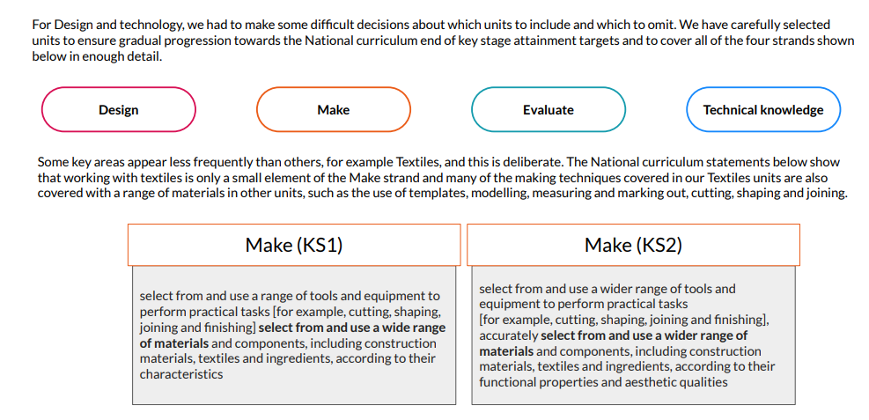

Slong-term plan: DT - Outline (EYFS: Reception)

 | Reception
Autumn term | Structures: Junk modelling  Exploring and learning about various types of permanent and temporary join. Pupils are encouraged to tinker using a combination of materials and joining techniques in the junk modelling area.
Spring term | Textiles: Bookmarks  Developing and practising threading and weaving techniques using various materials and objects. Pupils look at the history of the bookmark from Victorian times versus  modern-day styles. The pupils apply their knowledge and skills to design and sew their own bookmarks.
Summer term | Structures: Boats  Exploring what is meant by ‘waterproof’, ‘ﬂoating’ and ‘sinking’, pupils experiment and make predictions with various materials to carry out a series of tests. They learn about the different features of boats and ships before investigating their shape and structures to build their own.

long-term plan: DT - Outline (KS1)

 | Year 1 | Year 2
Autumn term | Structures: Constructing windmills  Designing, decorating and building a windmill for their mouse client to live in, developing an understanding of different types of windmill, how they work and their key features. | Structures: Baby bear's chair  Using the tale of Goldilocks and the Three Bears as inspiration, children help Baby Bear by making him a brand new chair. When designing the chair, they consider his needs and what he likes and explore ways of building it so that it is strong.
Spring term | .  Textiles: Puppets  Exploring different ways of joining fabrics before creating their own hand puppets based upon characters from a well-known fairytale. Children work to develop their technical skills of cutting, glueing, stapling and pinning. | Mechanisms: Making a moving monster  After learning the terms; pivot, lever and linkage, children design a monster which will move using a linkage mechanism. Children practise making linkages of different types and varying the materials they use to bring their monsters to life.
Summer term | Cooking and nutrition: Fruit and vegetables  Handling and exploring fruits and vegetables and learning how to identify which category they fall into, before undertaking taste testing to establish their chosen ingredients for the smoothie they will make a design packaging for. | Food: A balanced diet  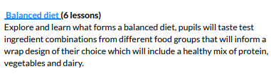

long-term plan: DT - Outline (Lower KS2)

 | Year 3 | Year 4
Autumn term | Structures: Constructing a castle  Learning about the features of a castle, children design and make one of their own. Using conﬁgurations of handmade nets and recycled materials to make towers and turrets and constructing a base to secure them. | Structures: Pavilions  Exploring pavilion structures, children learn about what they are used for and investigate how to create strong and stable structures before designing and creating their own pavilions, complete with cladding.
Spring term | Cooking and nutrition: Eating seasonally  Discovering when and where fruits and vegetables are grown. Learning about seasonality in the UK and the relationship between the colour of fruits and vegetables and their health beneﬁts by making three dishes. | Electrical systems: Torches  Applying their scientiﬁc understanding of electrical circuits, children create a torch, designing and evaluating their product against set design criteria.
Summer term | .  Cross Stitch: Cross Stitch and Applique- cushions  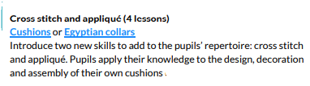 | Mechanical systems: Making a slingshot car  Transforming lollipop sticks, wheels, dowels and straws into a moving car. Using a glue gun to, making a launch mechanism, designing and making the body of the vehicle using nets and assembling these to the chassis.

long-term plan: DT - Outline (Upper KS2)

 | Year 5 | Year 6
Autumn term | Mechanical systems: Making a pop-up book  Creating a four-page pop-up storybook design incorporating a range of mechanisms and decorative features, including: structures, levers, sliders, layers and spacers. | Textiles: Waistcoats  Selecting suitable fabrics, using templates, pinning, decorating and stitching to create a waistcoat for a person or purpose of their choice.
Spring term | Cooking and nutrition: What could be healthier?  Researching and modifying a traditional bolognese sauce recipe to make it healthier. Children cook their healthier versions, making appropriate packaging and learn about farming cattle. | Structures: Playgrounds  Designing and creating a model of a new playground featuring ﬁve apparatus, made from three different structures. Creating a footprint as the base, pupils visualise objects in plan view and get creative with their use of natural features.
Summer term | Electrical systems: Doodlers  Explore series circuits further and introduce motors. Explore how the design cycle can be approached at a different starting point, by investigating an existing product, which uses a motor, to encourage pupils to problem-solve and work out how the product has been constructed, ready to develop their own. | Digital world: Navigating the world  Programming a navigation tool to produce a multifunctional device  for trekkers. Combining 3D objects to form a complete product in CAD 3D modelling software and presenting a pitch to 'sell' their product.

Version history

