Tutshill C. of E. Primary School
Curriculum Map 2023/24

KS1
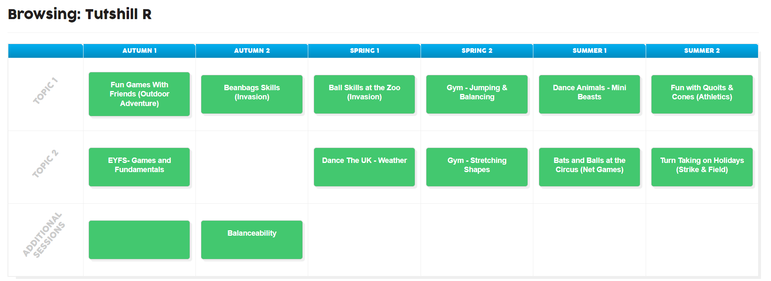
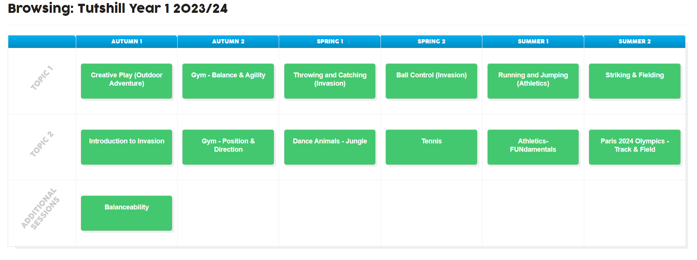
Year 2
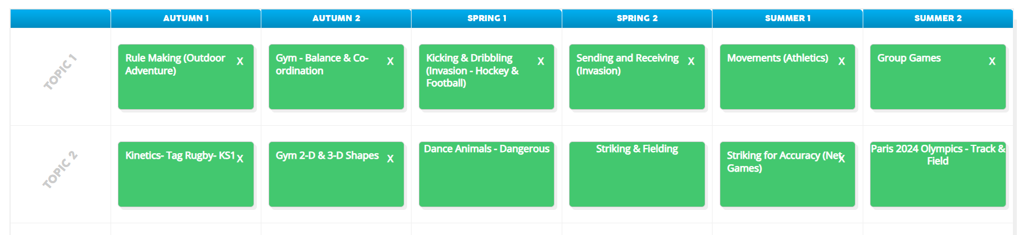

KS2
Year 3