# Pupil premium strategy statement

## This statement details our school’s use of pupil premium funding to help improve the attainment of our disadvantaged pupils.

## It outlines our pupil premium strategy, how we intend to spend the funding in this academic year and the effect that last year’s spending of pupil premium had within our school.

## School overview

|  |  |
| --- | --- |
| Detail | Data |
| School name | Tutshill C of E Primary School |
| Number of pupils in school | 212 |
| Proportion (%) of pupil premium eligible pupils | 8% |
| Academic year/years that our current pupil premium strategy plan covers | 2024-2027 |
| Date this statement was published | November 2024 |
| Date on which it will be reviewed | November 2027 |
| Statement authorised by | Emma Gomersall |
| Pupil premium lead | N Fryer |
| Governor / Trustee lead | Marion Evans |

**Funding overview**

|  |  |
| --- | --- |
| **Detail** | **Amount** |
| Pupil premium funding allocation this academic year | £ 38150 |
| Pupil premium funding carried forward from previous years (enter £0 if not applicable) | £0 |
| **Total budget for this academic year**  If your school is an academy in a trust that pools this funding, state the amount available to your school this academic year | £38150 |

# Part A: Pupil premium strategy plan

## Statement of intent

|  |
| --- |
| *At Tutshill C of E Primary school we are ambitious for our children and are committed to raising the achievement of all. We aim to help our children make progress by teaching them to be active, reflective learners, through an understanding and evaluative reflection of their key learning behaviours.*  *We value all children’s unique abilities and achievements and are committed to creating an environment where all children will thrive and grow. We aim to spend the Pupil Premium Grant in the most effective way and believe our approach needs to be flexible and responsive to the changing strengths and needs of our pupils.*  *Teachers work together with children to help them identify and understand their personal challenges and barriers to learning and develop ways to overcome them.*  *We believe in developing the whole child and use a holistic approach using a three tiered strategy to have the greatest impact.*  *1. Teaching: Improving the quality of teaching and providing professional development opportunities is at the forefront of our approach. Evidence strongly suggests that the most effective way to improve outcomes for disadvantaged children is through excellent classroom teaching. Ensuring an effective teacher is in front of every class, and that every teacher is supported to keep improving, is key to ensuring high quality provision for all.*  *2. Targeted academic support: We use a variety of one-to-one or small group interventions linked to effective classroom teaching and learning. Evidence consistently demonstrates the positive impact targeted academic support can have.*  *3. Wider strategies: Providing support in tackling the most significant, non-academic, barriers to success at school is the final, important tier. Such support includes addressing attendance issues and providing behaviour and social and emotional support.* |

## Challenges

This details the key challenges to achievement that we have identified among our disadvantaged pupils.

|  |  |
| --- | --- |
| Challenge number | Detail of challenge |
| 1 | The knowledge we have of our school community shows that some of our pupils and families have personal, emotional and health challenges which need supporting. |
| 2 | Our internal data and knowledge of our pupils show that disadvantaged children’s attainment in Reading, Writing and Maths is often below that of non- disadvantaged children. |
| 3 | Children who are disadvantaged often face further challenges if they also have special educational needs. This makes it harder for them to succeed in school- based learning and in wider life experiences. |
| 4 | Disadvantaged children’s learning is affected because they don’t always understand the most effective ways to think and learn or to monitor their own learning. |
| 5 | Our attendance monitoring suggests that disadvantaged children may face further challenges to their learning due to slightly higher levels of lateness. |
| 6 | Our internal data suggests that disadvantaged children’s learning may be affected by poor vocabulary and spoken language skills, impacting their language development, literacy and broader learning. |
| 7 | Disadvantaged children’s learning may be impacted by their limited access to wider learning enrichment opportunities. |

## Intended outcomes

This explains the outcomes we are aiming for **by the end of our current strategy plan**, and how we will measure whether they have been achieved.

|  |  |
| --- | --- |
| Intended outcome | Success criteria |
| *1 To improve well-being and learning the emotional needs of pupils will be well supported.* | Using our Trickbox scheme, children will be enabled to fully access the curriculum by being able to select and use a range of ‘Tricks’ and magic moments to support their confidence, communication, creativity and to create calm.  Children engage and are positive learners within lessons.  Positive mental health, emotional well-being and resilience are discussed within learning and acts of worship.  Children demonstrate strong resilience effectively handling challenges and adapting to changing situations.  The self-esteem of disadvantaged children is raised |
| 2 Specific gaps in learning will be addressed through targeted interventions | Participate in the Write Journey training programme- EEF researched backed intervention.  Pupils will have the knowledge and understanding to actively access class-based learning alongside their peers. |
| 3 Children with SEN will make good or better progress (80% of My Plan targets met.) | With support, pupils will have the self -confidence to be able to access differentiated class-based learning alongside their peers |
| 4 A metacognitive approach to teaching and learning will be used by children and teachers using the ABCDE model | Pupils will understand which learning behaviours to use for different tasks and reflect on their learning systematically. Focus on peer and adult coaching as a way of supporting learning. |
| 5 Attendance and punctuality will improve in line with non -disadvantaged pupils | Pupils will make progress due to being able to fully engage with all learning including early morning interventions. Pupils will gain confidence from being involved with all aspects of daily learning. |
| 6 Disadvantaged children will develop their vocabulary and spoken language skills through Increased oral language and listening opportunities | Pupils will make progress through an increased class and intervention-based focus on vocabulary, language and the spoken word, to bring their language in-line with non-disadvantaged peers. |
| 7 Disadvantaged children will have access to funded musical, art or sport enrichment activities. | Pupils will have the same opportunities as non-disadvantaged pupils.  PP children will attend 1 after school club/ learn a musical instrument.  PP children will have the opportunity to attend sporting events/ after school clubs  PP children will wear school uniform. |

## Activity in this academic year

This details how we intend to spend our pupil premium (and recovery premium funding) **this academic year** to address the challenges listed above.

### Teaching (for example, CPD, recruitment and retention)

Budgeted cost: £ *13,630*

|  |  |  |
| --- | --- | --- |
| Activity | Evidence that supports this approach | Challenge number(s) addressed |
| *Whole school CPD curriculum development, reflection and coaching strategies within metacognition teaching and learning.*  *Lead teachers training for Write Journey training* | *EEF- The potential impact of metacognition and self-regulation approaches is high (+7 months additional progress)*  *Metacognition and self-regulation strategies can be effective when taught in collaborative groups so that learners can support each other and make their thinking explicit through discussion*.  *Isner and colleagues (2011) examined 48 studies. The studies reviewed showed positive changes on measures of classroom quality as well as on specific measures of interactional or teaching practices. In 31 of the 48 studies, coaching was focused either on practices to improve overall classroom or environmental quality or specific teaching practices, particularly practices to support young children’s language and literacy development.*  *Developing strategies to develop quality first teaching is important, the EEF suggests there is “strong evidence that high-quality teaching for pupils with SEND is firmly based on strategies that will already be in the repertoire of every mainstream teacher, or can be relatively easily added to it* | 4, 2 |
| *Develop’ leading learning’ support for key pupils, supporting understanding and use of key learning behaviours* | *EEF- The potential impact of metacognition and self-regulation approaches is high (+7 months additional progress)*  *EEF-Teachers should explicitly support pupils to develop independent learning skills*  *Explicit instruction in cognitive and metacognitive strategies can improve pupils’ learning, strategies are mostly applied in relation to specific content and tasks, and are therefore best taught this way* | 4 |
| *Embed and review rising stars phonics scheme and rocket readers as part of literacy strategy.*  *Ensure all staff receive ongoing relevant training and support to deliver the phonics scheme.* | *EEF-Phonics has a positive impact overall (+5 months) with very extensive evidence and is an important component in the development of early reading skills, particularly for children from disadvantaged backgrounds.* | 2 |
| *Embed White Rose Mathematics scheme including formative and summative assessment package Maths.co.uk*  *Continue to embed Glow Maths Mastery across the school* | *EEF-*Assessment *should be used not only to track pupils’ learning but also to provide teachers with information about what pupils do and do not know. This should inform the planning of future lessons and the focus of targeted support.*  *Studies in primary school settings have shown 8 months additional progress. A high level of mastery of about 80% is associated with more successful approaches.* | 2 |
| *Use of a scaffolding approach-through ABCDE model- in English and Mathematics and foundation subjects, within class and intervention group, to support learners and extend learning* | *EEF-Approaches such as explicit instruction, scaffolding and flexible grouping are all key components of high-quality teaching and learning for pupils.*  *Scaffolded tasks, like worked examples, allow pupils to develop their metacognitive and cognitive skills without placing too many demands on their mental resources.* | 2,3 |
| *Increased daily reading opportunities including whole class book and author focus* | *The attainment gap between disadvantaged children and their more affluent peers opens early and continues throughout schooling. There is a wealth of evidence to show that early intervention has great potential to narrow the gap…These impacts on language skills were still seen 6 months after the intervention* | 2, 6 |

**Targeted academic support (for example, tutoring, one-to-one support structured interventions)**

Budgeted cost: £ *16,200*

|  |  |  |
| --- | --- | --- |
| Activity | Evidence that supports this approach | Challenge number(s) addressed |
| *Classroom based ‘focused teaching’ interventions to address widening gaps between disadvantaged and non- disadvantaged pupils, in English and mathematics.* | *Small group tuition approaches can support pupils to make effective progress by providing intensive, targeted academic support to those identified as having low prior attainment or at risk of falling behind. The approach allows the teacher to focus on the needs of a small number of learners and provide teaching that is closely matched to pupil understanding. Small group tuition offers an opportunity for greater levels of interaction and feedback compared to whole class teaching which can support pupils to overcome barriers to learning and increase their access to the curriculum.* | 2 |
| *HLTA run interventions to address the widening gaps between disadvantaged and non- disadvantaged pupils in English and mathematics* | *Research which focuses on teaching assistants who provide one to one or small group targeted interventions shows a stronger positive benefit of between four and six additional months on average.-EEF* | 2 |
| *Class based targeted interventions to support reflection on learning behaviours and metacognition.* | *Developing pupils’ metacognitive knowledge of how they learn — their knowledge of themselves as a learner, of strategies, and of tasks — is an effective way of improving pupil outcomes.* | 4 |
| *learning ambassador focus to develop key learning behaviours through leading learning and interventions,* | *EEF-Teachers should explicitly support pupils to develop independent learning skills. Carefully designed  guided practice with support gradually withdrawn as the pupil becomes proficient, can allow pupils to develop skills and strategies before applying them in independent practise.* | 4 |
| *Key support during lessons,e.g.additional TA/CT support directed questioning, high quality feedback,* | *EEF-  Providing feedback is  well-evidenced and has a high impact on learning outcomes. Effective feedback tends to focus on the task, subject and self-regulation strategies: it provides specific information on how to improve.* | 2 |
| *Speech and Language interventions, including Vocabulary focus.* | *The average impact of Oral language interventions is approximately an additional six months’ progress over the course of a year*  *There is evidence to suggest that pupils from lower socioeconomic backgrounds are more likely to be behind their more advantaged counterparts in developing early language and speech skills, which may affect their school experience and learning later in their school lives.* | 2 4 6 |
| *Increased reading opportunities for all children but specifically targeted for lowest 20%* | *EEF-even when excellent classroom teaching is in place, it is likely that a small but significant number of children will require additional targeted literacy support.*  *annual literacy survey 2022- The research shows that enjoying reading and reading daily has a positive relationship with children's reading abilities. Children who enjoy reading are three times more likely to read above the level expected for their age than children who don’t enjoy it, and those who read daily in their free time are twice as likely to read above the expected level.* | 2,4, 6 |
| *Teacher led, after school tutoring for key groups, Spring term* | *EEF- tuition is likely to be most effective when it is targeted. Targeted tuition is likely to be well matched to a pupils’ current curriculum, so that they can reinforce learning from tuition sessions in their classroom practice.* | 2 |

**Wider strategies (for example, related to attendance, behaviour, wellbeing)**

Budgeted cost: £ *8,320*

|  |  |  |
| --- | --- | --- |
| Activity | Evidence that supports this approach | Challenge number(s) addressed |
| Specific personal, social, emotional, academic interventions to support pupils with multiple vulnerabilities including those with EHCP and SEND | *Pupils with Special Educational Needs and Disability (SEND) have the greatest need for excellent teaching and are entitled to provision that supports achievement at, and enjoyment of, school…*  *However, pupils with SEND are also more than twice as likely to be eligible for free school meals.* | 3 |
| To develop self -regulation skills and well- being through the use of Trickbox | *such methods require pupils to take greater responsibility for their learning and develop their understanding of what is required to succeed.*  *The evidence indicates that explicitly teaching strategies to help plan, monitor and evaluate specific aspects of their learning can be effective.*  *The impact of self-regulation strategies is an additional seven months’ progress over the course of a year.* | 1, 4 |
| Trickbox at home learning programme engaging and supporting parents | Focus on building parents’ efficacy: that they are equal partners and can make a difference. Encourage a consistent approach to behaviour between parents and the school, for example, by sharing expectations with parents.  Offering more structured, evidence-based programmes can help to develop positive behaviour and consistency where needs area greater.  *It is beneficial to share these strategies with families so they can support self-regulation at home: setting goals, planning and managing time, effort and emotions.* | 1,4 |
| To support children’s social and emotional learning through ‘Time to flourish’ provision, including lunch club, and/or ELSA trained support staff led opportunities. | Being able to effectively manage emotions will be beneficial to children and young people even if it does not translate to reading or maths scores. Evidence suggests that children from disadvantaged backgrounds have, on average, weaker SEL skills at all ages than their more affluent peers. These skills are likely to influence a range of outcomes for pupils: lower SEL skills are linked with poorer mental health and lower academic attainment. | 1,3,4 |
| To improve the attendance and punctuality of children through parental engagement.  Develop and use school based systems to show our commitment to the importance of attendance and punctuality. | DFE research 2012 There is a clear link between poor attendance and lower academic achievement.  Attendance and punctuality play a huge role in increasing children's academic success. When students are not in class they miss out on a wealth of knowledge as well as continuity of learning  *WPA- Research shows that effective engagement often leads to increased attendance and it can also be linked to higher academic achievement and to a positive effect on pupil’s attitude to learning and on their behaviour.* | 5 |
| To offer enrichment activities including  whole class music lessons,subsidised sports clubs, breakfast/ after school club, music lessons for children in receipt of FSM. | *Not all learning takes place in the classroom. Children and young people gain a lot from their experiences on schools trips and extra-curricular activities …but many children and young people from poor families miss out on these (extra-curricular activities) because their parents cannot afford the cost.* | 1, |
| Provide a uniform grant for children in receipt of FSM | *School uniform policies are thought to complement the development and support of a whole school culture and approach, which in turn may assist pupil discipline and motivation.* | 1 |

**Total budgeted cost: £***39.000*

# Part B: Review of outcomes in the previous academic year

## Pupil premium strategy outcomes

Outcome 1

Provision for the emotional well-being of children has continued to be supported through our active and needs-led provision. These have included ELSA sessions, Learn to Flourish and Time to Flourish sessions, lunch time support clubs, social skills groups and mental well-being clubs. Pastoral Support Plans, My Plans and Individual Learning Plans form part of our offer of Early Help.

Trickbox is used in addition to PSHE lessons and provides all children with a range of strategies to support their well-being. Parent support workshops have taken place to provide support for families.

TAF meetings are instigated to support the needs of families and develop collaborative working practices with families and wider external professionals.

100% of PP children (9) attending time to flourish achieved their target.

A further 11 PP children received support from Learn to Flourish sessions, which supported their well-being through learning tasks. The learning behaviours related to curiosity, resilience, reflection, cooperation and resourcefulness were worked on.

Comments from pupil voice include,

“I feel less frustrated here with my work”

(I’ve learned) “ Working with others is better than working by myself”

(I’ve learned) “ how to think back and talk about myself ( as a learner) “

Xxx PP children received ELSA support. Xxx % achieved their target.

We work closely with a range of external professionals to support the needs of pupils. This year we have accessed support from educational psychologists, children’s mental health practitioners, including 1:1 sessions, group and whole class interventions; family support workers, therapists, speech and language therapists, health professionals.

## Outcome 2 specific gaps in learning will be addressed through targeted interventions

100% of children in receipt of Pupil Premium have received targeted interventions, either in class or within focus groups. Interventions have run for reading, writing, maths and phonics with the aim of supporting and building on class-based learning

and to close any identified gaps in learning. Progress against focussed criteria is assessed and shared by intervention staff with class-based staff to ensure skills are transferred for all contexts.

Published Data.

|  |  |  |
| --- | --- | --- |
| Assessments | Whole School data | PP data |
| EYFS GLD | 80% | 2/2 |
| Phonics Yr 1 | 90% | 100% |
| Phonics Yr 2 | 100% | N/A |
| KS1 Reading | 80% | 1/2 |
| KS1 Writing | 73% | 1/2 |
| KS1 Maths | 80% | 0/2 |
| KS1 Science | 83% | 1/2 |
| Yr 4 multiplication check | Average score 20.0 |  |
| KS2 Reading | 83% Average scaled score 106.7 | 2/2 |
| KS2 Writing | 83% | 2/2 |
| KS2 Maths | 57% Average scaled score 101.3 | 1/2 |
| KS2 grammar, punctuation and spelling | 77% Average scaled score 106.3 | 1/2 |
| KS2 Science | 90% | 2/2 |

**Learning Progress**

**Green bar showing expected progress, red bar showing below expected progress, blue bar showing above expected progress.**

**Progression of all children from Summer 2022 to Summer 2023**

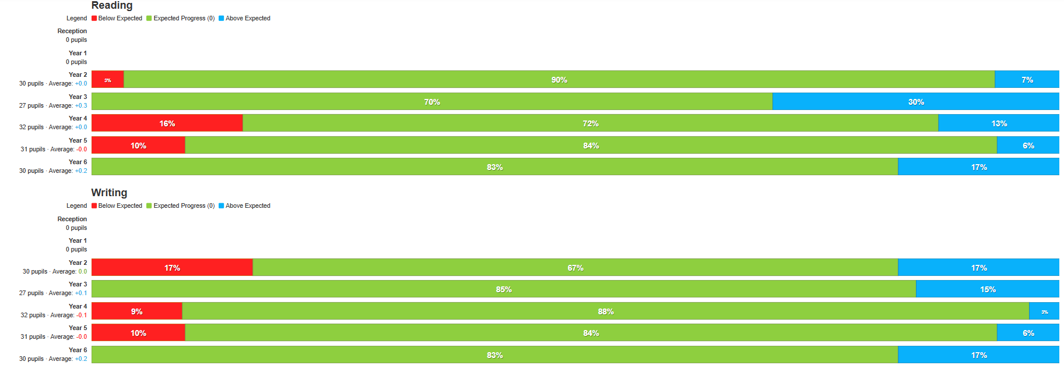

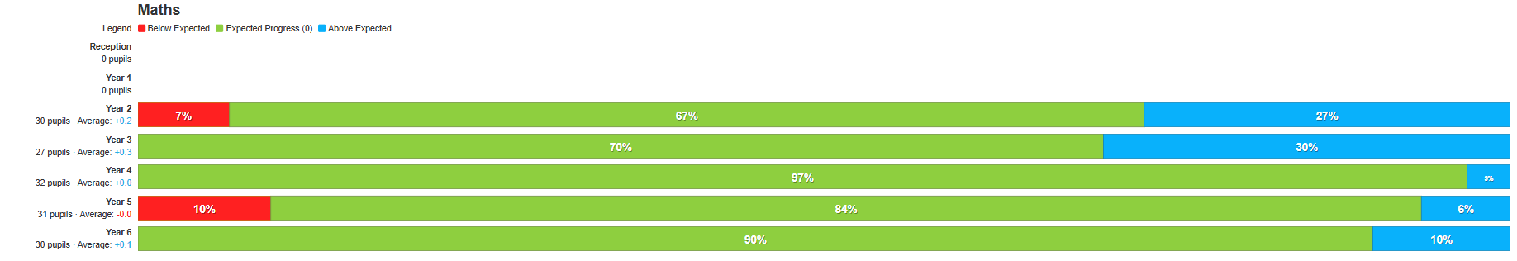

**Compared to**

**Progression of disadvantaged children from Summer 2022 to Summer 2023**

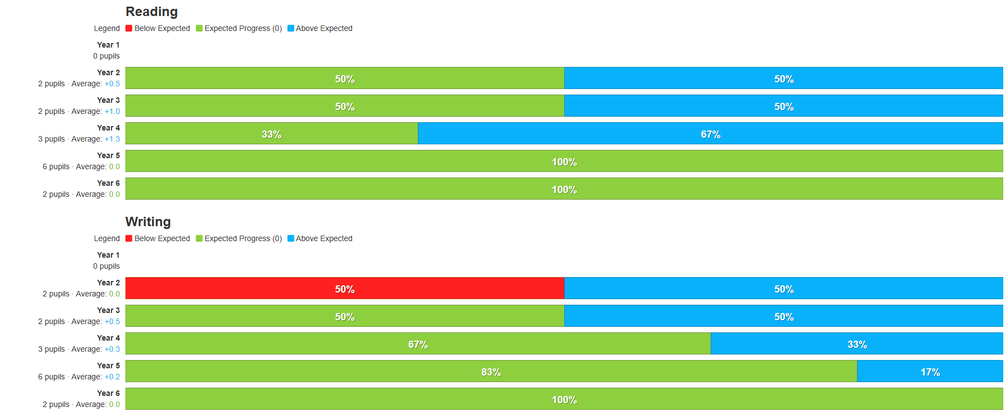

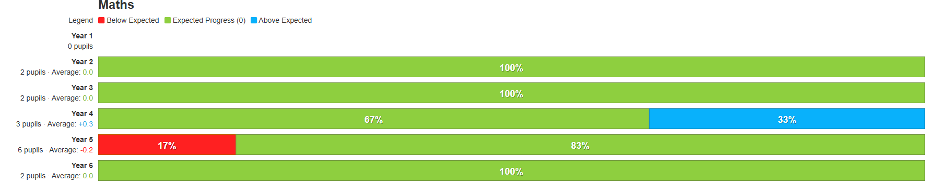

## Outcome 3

43%, 9/21 children in receipt of Pupil Premium had SEND support.

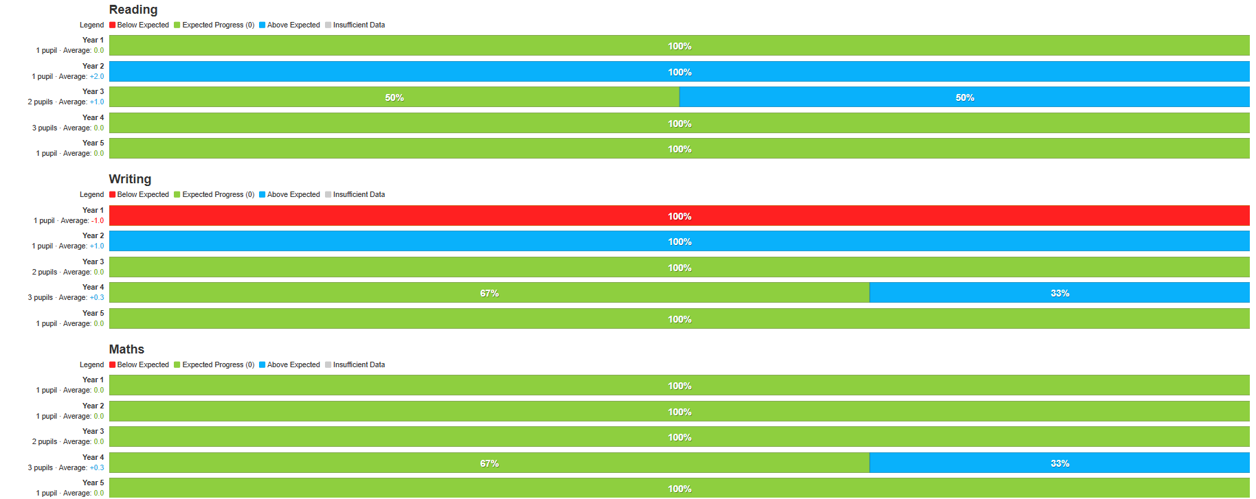

Progress for children in receipt of Pupil Premium with SEND was at least good in reading and maths, and in writing for 89% of children.

This progress is on par with Pupil Premium children with no SEND and better than all pupils.

My Plan targets are set and reviewed termly, progress is measured against three targets set for each child with a My Plan.

Learn to Flourish sessions have focussed on Curiosity, resilience, reflection, cooperation and resourcefulness.

## Outcome 4

The use of a Metacognitive approach.

All staff have been trained in Teaching and Learning approaches using a metacognitive approach. Tutshill School use the ABCDE model of teaching and learning to support the development of children’s metacognition.

Resilience is a learning behaviour which has been targeted and is the certificate and sticker most rewarded for learning, followed by resourcefulness. This reflects the work completed during learn to flourish sessions.

## Outcome 5

Attendance for disadvantaged pupils is similar to non-disadvantaged. Absence is monitored and support put in place to help families ensure that children are attending school regularly and on time.

|  |  |  |
| --- | --- | --- |
|  | Disadvantaged | Non- disadvantaged |
| Persistently absent | 5.6 % | 7.2% |
| At risk of persistent absence | 50% | 26.9% |
| Late before register closed | 122 sessions (6.7%) | 1072 sessions (6.4%) |

## Outcome 6

The development of vocabulary and spoken skills have been a key driver for all areas of the curriculum. Subject leaders and class teachers have developed clear vocabulary progression to support the development of spoken language and the understanding of key vocabulary.

All subject leaders identify key vocabulary and have developed learning schemas to support children’s use and understanding of key terms. A focus on developing reading skills for all children. But particularly those in receipt of pupil premium has been a key driver.

The at home learning resources as part of the phonics scheme continue to be used by families. Reading materials closely match the needs of all children.

Frequent opportunities to read with disadvantaged children, further develop their spoken and verbal language skills.

## Outcome 7

Musical enrichment opportunities are provided for all children to inspire and enrich the curriculum. This includes; whole class instrument tuition, music performances, including drumming, swing band, piano recitals, vocal/choral recitals.

Extra curricula

All children in receipt of Pupil Premium are offered one free enrichment club a year.

All disadvantaged children are offered the opportunity to represent their school at sporting competitions.

## Externally provided programmes

*Please include the names of any non-DfE programmes that you purchased in the previous academic year. This will help the Department for Education identify which ones are popular in England*

|  |  |
| --- | --- |
| Programme | Provider |
| TrickBox | Trickbox |
| TT Rockstars |  |
| White Rose Maths scheme | White Rose |
| Rocket Readers synthetic phonics | Rising Stars |

**Service pupil premium funding (optional**)

|  |  |
| --- | --- |
| Measure Details | What was the impact of that spending on |
| class based support  External professional support, Educational Psychology  Nurture/ Elsa- support provided- teaching time and lunchtime support  Class based and HLTA Interventions | children were able to access class-based learning.  Individual learning needs identified and supported  Individual personal and social challenges addressed and supported  individual barriers to learning addressed. |