Pupil premium strategy statement

This statement details our school’s use of pupil premium (and recovery premium for the 2022 to 2023 academic year) funding to help improve the attainment of our disadvantaged pupils.

It outlines our pupil premium strategy, how we intend to spend the funding in this academic year and the effect that last year’s spending of pupil premium had within our school.

School overview
Detail | Data
School name | Tutshill C of E Primary School
Number of pupils in school | 212
Proportion (%) of pupil premium eligible pupils | 11%
Academic year/years that our current pupil premium strategy plan covers | 2021-2024
Date this statement was published | September 2022
Date on which it will be reviewed | September 2023
Statement authorised by | J Lane
Pupil premium lead | N Fryer
Governor / Trustee lead | Mrs H Rowlands
Funding overview
Detail | Amount
Pupil premium funding allocation this academic year | 31895
Recovery premium funding allocation this academic year | 2320
Pupil premium funding carried forward from previous years (enter £0 if not applicable) | £983
Total budget for this academic year  If your school is an academy in a trust that pools this funding, state the amount available to your school this academic year | £35 198

Part A: Pupil premium strategy plan

Statement of intent
At Tutshill C of E Primary school we are ambitious for our children and are committed to raising the achievement of all. We aim to help our children make progress by teaching them to be active, reflective learners, through an understanding and evaluative reflection of their key learning behaviours.
We value all children’s unique abilities and achievements and are committed to creating an environment where all children will thrive and grow. We aim to spend the Pupil Premium Grant in the most effective way and believe our approach needs to be flexible and responsive to the changing strengths and needs of our pupils.
Teachers work together with children to help them identify and understand their personal challenges and barriers to learning and develop ways to overcome them.
We believe in developing the whole child and use a holistic approach using a three tiered strategy to have the greatest impact.
1. Teaching: Improving the quality of teaching and providing professional development opportunities is at the forefront of our approach. Evidence strongly suggests that the most effective way to improve outcomes for disadvantaged children is through excellent classroom teaching. Ensuring an effective teacher is in front of every class, and that every teacher is supported to keep improving, is key to ensuring high quality provision for all.
2. Targeted academic support: We use a variety of one-to-one or small group interventions linked to effective classroom teaching and learning. Evidence consistently demonstrates the positive impact targeted academic support can have.
3. Wider strategies: Providing support in tackling the most significant, non-academic, barriers to success at school is the final, important tier. Such support includes addressing attendance issues and providing behaviour and social and emotional support.

Challenges

This details the key challenges to achievement that we have identified among our disadvantaged pupils.
Challenge number | Detail of challenge
1 | Emotional needs including attachment issues
2 | Misconceptions and specific academic gaps in learning, specifically reading and writing.
3 | Impact of having SEN compounded by disadvantage
4 | Impact of lack of understanding of appropriate thinking and Learning Behaviours
5 | Negative impact of slightly lower rates of attendance and poor punctuality.
6 | Impact of poor vocabulary and spoken language on language, literacy and wider learning.
7 | Impact of disadvantage in accessing disawider learning enrichment opportunities.

Intended outcomes
This explains the outcomes we are aiming for by the end of our current strategy plan, and how we will measure whether they have been achieved.
Intended outcome | Success criteria
1 Emotional well- being of pupils will be well supported | Pupils will be enabled to fully access the curriculum by being able to select and use a range of ‘Tricks’ to support their confidence, communication, creativity and to create calm.
2 Specific gaps in learning will be addressed through targeted interventions | Pupils will have the knowledge and understanding to actively access class based learning alongside their peers.
3 Children with SEN will make good or better progress (80% of My Plan targets met.) | With support, pupils will have the self -confidence to be able to access differentiated class based learning alongside their peers
4 A metacognitive approach to teaching and learning will be used by children and teachers using the ABCDE model | Pupils will understand which learning behaviours to use for different tasks and reflect on their learning systematically.
5 Attendance and punctuality will improve in line with non -disadvantaged pupils | Pupils will make progress due to being able to fully engage with all learning including early morning interventions. Pupils will gain confidence from being involved with all aspects of daily learning.
6 Disadvantaged children will develop their vocabulary and spoken language skills through Increased oral language and listening opportunities | Pupils will make progress through an increased class and intervention based focus on vocabulary, language and the spoken word, to bring their language in-line with non-disadvantaged peers.
7 Disadvantaged children will have access to funded musical, art or sport enrichment activities. | Pupils will have the same opportunities as non-disadvantaged pupils .  PP children will attend 1 after school club/ learn a musical instrument.  PP children will have the opportunity to attend sporting events/ after school clubs  PP children will wear school uniform.

Activity in this academic year
This details how we intend to spend our pupil premium (and recovery premium funding) this academic year to address the challenges listed above.

Teaching (for example, CPD, recruitment and retention)
Budgeted cost: £ [20,000]
Activity | Evidence that supports this approach | Challenge number(s) addressed
whole school CPD curriculum development, reflection within metacognition teaching and learning. | EEF- The potential impact of metacognition and self-regulation approaches is high (+7 months additional progress)  Metacognition and self-regulation strategies can be effective when taught in collaborative groups so that learners can support each other and make their thinking explicit through discussion. | 4
rollout embed and review rising stars phonics scheme and rocket readers.  Ensure all staff have received ongoing relevant training and support to deliver the phonics scheme. | EEF-Phonics has a positive impact overall (+5 months) with very extensive evidence and is an important component in the development of early reading skills, particularly for children from disadvantaged backgrounds. | 2
Embed new White Rose Mathematics scheme including formative and summative assessment package | EEF-Assessment should be used not only to track pupils’ learning but also to provide teachers with information about what pupils do and do not know. This should inform the planning of future lessons and the focus of targeted support. | 2
Use of a scaffolding approach in English and Mathematics, within class and intervention group, to support learners and extend learning | EEF-Approaches such as explicit instruction, scaffolding and flexible grouping are all key components of high-quality teaching and learning for pupils.  Scaffolded tasks, like worked examples, allow pupils to develop their metacognitive and cognitive skills without placing too many demands on their mental resources. | 2,3
Increased daily reading opportunities including whole class book and author focus | The attainment gap between disadvantaged children and their more affluent peers opens early and continues throughout schooling. There is a wealth of evidence to show that early intervention has great potential to narrow the gap…These impacts on language skills were still seen 6 months after the intervention | 2, 6

Targeted academic support (for example, tutoring, one-to-one support structured interventions)
Budgeted cost: £ [8800]
Activity | Evidence that supports this approach | Challenge number(s) addressed
Classroom based ‘focused teaching’ interventions to address widening gaps between disadvantaged and non- disadvantaged pupils, in English and mathematics. | Small group tuition approaches can support pupils to make effective progress by providing intensive, targeted academic support to those identified as having low prior attainment or at risk of falling behind. The approach allows the teacher to focus on the needs of a small number of learners and provide teaching that is closely matched to pupil understanding. Small group tuition offers an opportunity for greater levels of interaction and feedback compared to whole class teaching which can support pupils to overcome barriers to learning and increase their access to the curriculum. | 2
HLTA run interventions to address the widening gaps between disadvantaged and non- disadvantaged pupils in English and mathematics | Research which focuses on teaching assistants who provide one to one or small group targeted interventions shows a stronger positive benefit of between four and six additional months on average.-EEF | 2
Class based targeted interventions to support reflection on learning behaviours and metacognition. | Developing pupils’ metacognitive knowledge of how they learn — their knowledge of themselves as a learner, of strategies, and of tasks — is an effective way of improving pupil outcomes. | 4
learning ambassador focus to develop key learning behaviours through HLTA interventions, | EEF-Teachers should explicitly support pupils to develop independent learning skills. Carefully designed guided practice with support gradually withdrawn as the pupil becomes proficient, can allow pupils to develop skills and strategies before applying them in independent practise. | 4
Key support during lessons,e.g.additional TA/CT support directed questioning, high quality feedback, | EEF- Providing feedback is well-evidenced and has a high impact on learning outcomes. Effective feedback tends to focus on the task, subject and self-regulation strategies: it provides specific information on how to improve. | 2
Speech and Language interventions, including Vocabulary focus. | The average impact of Oral language interventions is approximately an additional six months’ progress over the course of a year  There is evidence to suggest that pupils from lower socioeconomic backgrounds are more likely to be behind their more advantaged counterparts in developing early language and speech skills, which may affect their school experience and learning later in their school lives. | 2 4 6
Increased reading opportunities for all children but specifically targeted for lowest 20% | EEF-even when excellent classroom teaching is in place, it is likely that a small but significant number of children will require additional targeted literacy support.  annual literacy survey 2022- The research shows that enjoying reading and reading daily has a positive relationship with children's reading abilities. Children who enjoy reading are three times more likely to read above the level expected for their age than children who don’t enjoy it, and those who read daily in their free time are twice as likely to read above the expected level. | 2,4, 6

Wider strategies (for example, related to attendance, behaviour, wellbeing)
Budgeted cost: £ [6700]
Activity | Evidence that supports this approach | Challenge number(s) addressed
Specific personal, social, emotional, academic interventions to support pupils with multiple vulnerabilities including those with EHCP and SEND | Pupils with Special Educational Needs and Disability (SEND) have the greatest need for excellent teaching and are entitled to provision that supports achievement at, and enjoyment of, school…  However, pupils with SEND are also more than twice as likely to be eligible for free school meals. | 3
To develop self -regulation skills and well- being through the use of Trickbox | such methods require pupils to take greater responsibility for their learning and develop their understanding of what is required to succeed.  The evidence indicates that explicitly teaching strategies to help plan, monitor and evaluate specific aspects of their learning can be effective.  The impact of self-regulation strategies is an additional seven months’ progress over the course of a year. | 1, 4
Trickbox at home learning programme engaging and supporting parents | Focus on building parents’ efficacy: that they are equal partners and can make a difference. Encourage a consistent approach to behaviour between parents and the school, for example, by sharing expectations with parents.  Offering more structured, evidence-based programmes can help to develop positive behaviour and consistency where needs area greater.  It is beneficial to share these strategies with families so they can support self-regulation at home: setting goals, planning and managing time, effort and emotions. | 1,4
To support children’s social and emotional learning through Nurture provision, including lunch club, and/or ELSA trained support staff led opportunities. | Being able to effectively manage emotions will be beneficial to children and young people even if it does not translate to reading or maths scores. Evidence suggests that children from disadvantaged backgrounds have, on average, weaker SEL skills at all ages than their more affluent peers. These skills are likely to influence a range of outcomes for pupils: lower SEL skills are linked with poorer mental health and lower academic attainment. | 1,3,4
To improve the attendance and punctuality of children through parental engagement.  Develop and use school based systems to show our commitment to the importance of punctuality. | DFE research 2012 There is a clear link between poor attendance and lower academic achievement.  Attendance and punctuality play a huge role in increasing children's academic success. When students are not in class they miss out on a wealth of knowledge as well as continuity of learning  WPA- Research shows that effective engagement often leads to increased attendance and it can also be linked to higher academic achievement and to a positive effect on pupil’s attitude to learning and on their behaviour. | 5
To offer enrichment activities including  subsidised sports clubs, breakfast/ after school club, music lessons for children in receipt of FSM. | Not all learning takes place in the classroom. Children and young people gain a lot from their experiences on schools trips and extra-curricular activities …but many children and young people from poor families miss out on these (extra-curricular activities) because their parents cannot afford the cost. | 1,
Provide a uniform grant for children in receipt of FSM | School uniform policies are thought to complement the development and support of a whole school culture and approach, which in turn may assist pupil discipline and motivation. | 1

Total budgeted cost: £ []35000

Part B: Review of outcomes in the previous academic year

Pupil premium strategy outcomes
Pupil Premium Review
Outcome 1
Emotional well-being of pupils will be well supported.
Provision for the emotional well-being of children has continued to be supported through our active and needs-led pastoral provision. These have included, ELSA sessions, ‘Busy Bee’ nurture provision, lunchtime support clubs, social skills groups and mental well-being clubs. Pastoral support plans, My Plans and Individual Learning Plans form part of our offer of Early Help.
Trickbox is used in addition to PSHE lessons and provides all children with a range of strategies to support their own well-being. Parent workshops have taken place to provide support for families. Parent sessions were used to help parents support the work done in school, at home. 10 families worked with staff to learn how to support their own understanding of stress and how to support children using Trickbox parenting workshop strategies.
Data from ELSA support sessions shows that ,100% of children ( 17) who received support showed improved scores.
100% of children who receive Boxall assessments show improvements in scores across the sessions.
16/27- 59% children in receipt of PP attended lunchtime pastoral support groups

We work closely with a range of external professionals to support the needs of all pupils.
This year we have accessed support from educational psychologists, children’s mental health practitioners, Family support workers, therapists, speech and language therapists, specialist occupational therapists.
10 children have received focused support during this academic year.

Outcome 2.
Specific gaps in learning will be addressed through targeted interventions
100% children in receipt of Pupil Premium have received targeted interventions for reading, writing, phonics and maths, in class as well as external provision over the year to support class based learning and to close any identified gaps in learning. Progress against focussed criteria is assessed and shared by intervention staff with class based staff to ensure skills are transferred for all contexts.
Attainment and progress for pupil premium children is shown in the tables below.

This table highlights in green the % of pupil premium children who are working at the expected level, orange just below the expected level and red below the expected level.
All pupil premium children end of year attainment against Age Related Expectations
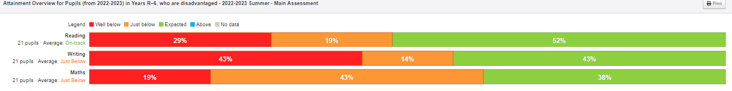
Compared with end of year attainment against Age Related expectations for children in receipt of FSM
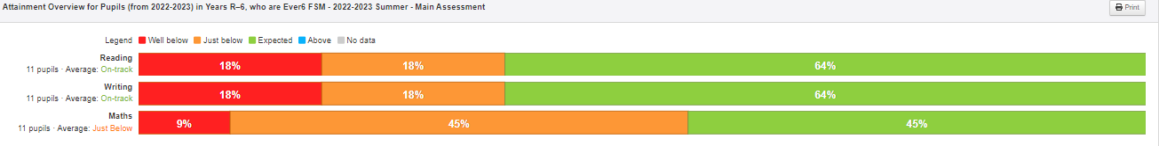

Compared with end of year attainment against Age Related expectations for All children
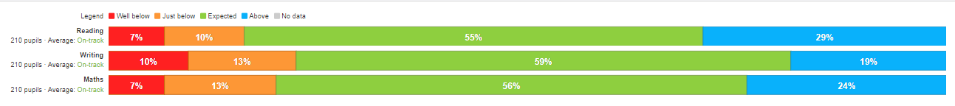

This table highlights in blue pupil premium children who have progressed beyond the expected level, green- those who have made expected progress and red those who have not made the expected level of progress. Grey shows children without progress data- those who have joined the school in the last year.
Progress of all Pupil Premium children over the academic year

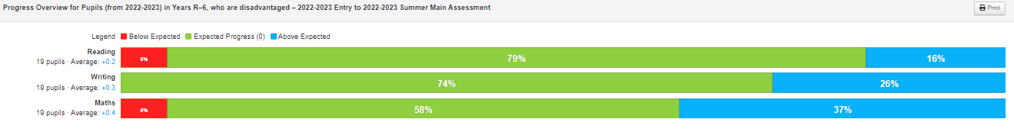

Compared with progress for children in receipt of FSM
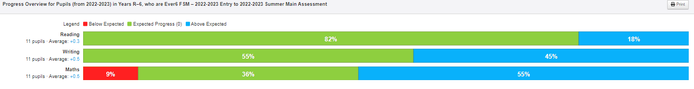

Compared with progress for All children
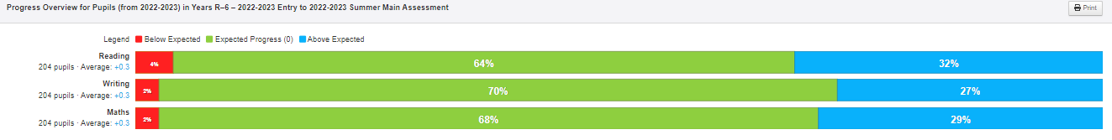

End of year attainment Pupil Premium no SEND
This table highlights in green the % of children who are working at the expected level, orange just below the expected level and red below the expected level.

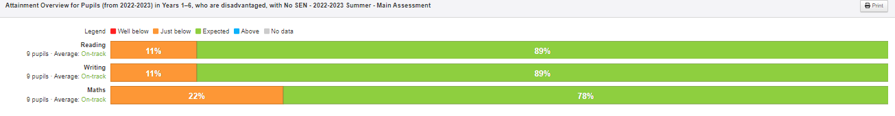

Progress of Pupil Premium no SEND
This table highlights in blue children who have progressed beyond the expected level, green- those who have made expected progress and red those who have not made the expected level of progress.
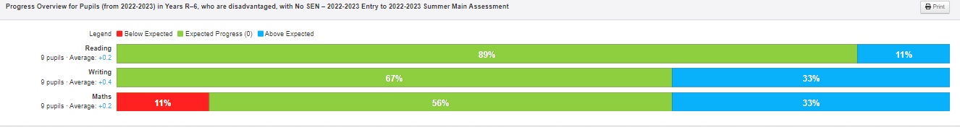

End of year attainment Pupil Premium children with SEND
This table highlights in green the % of children who are working at the expected level, orange just below the expected level and red below the expected level.

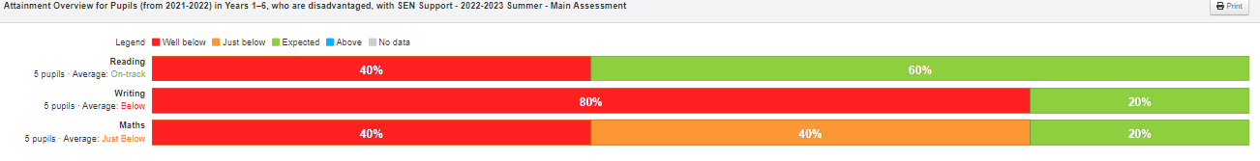

Progress of Pupil Premium with SEND
This table highlights in blue children who have progressed beyond the expected level, green- those who have made expected progress and red those who have not made the expected level of progress..
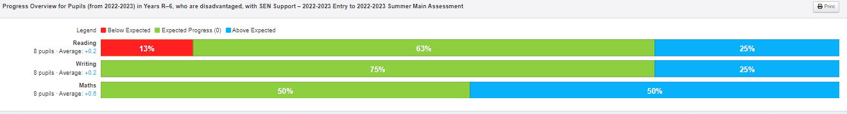
Progress of all pupils with SEND
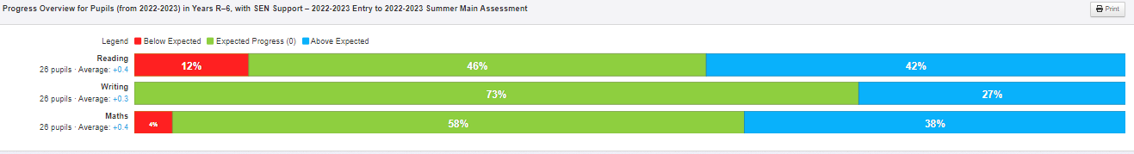
Quality first teaching and focused interventions are allowing Pupil Premium children to make accelerated progress in writing and maths and progress in line with expectations for reading.

Outcome 3
54%- 14/26 children in receipt of Pupil Premium had SEND support.
Progress for children in receipt of Pupil Premium with SEND was at least good or better. 1 child did not make at least good progress against their starting point.
This is on a par with Pupil Premium children with no SEND and better than non-pupil premium children.
My Plan targets are set and reviewed termly, progress is measured against the 5 targets set for each child with a My Plan.

Outcome 4
The use of a metacognitive approach.
All staff have been trained in Teaching and Learning approaches using a metacognitive approach. Tutshill School use the ABCDE model of teaching and learning to support the development of children’s metacognition. https://www.tutshillcofeschool.co.uk/web/teaching_and_learning_/664846
The use of stickers and reward systems supports the delivery of metacognitive learning as part of the overall school vision.
Data shows that the learning behaviours targeted for children in receipt of PP are reflection and resilience.
Monitoring shows that all subject leaders report that the ABCDE model is used to teach all subjects. Children are able to discuss how lessons start with activating learning and they build on what they know and can do, returning to specific learning but in new and interesting ways.
Pupil conferencing highlights that children from all year groups talk about learning behaviours used within learning and are able to identify how specific learning behaviours support their learning.
Comments include,
“I show resilience, risk taking, courage ( in learning), with four different styles of one picture-it me a long time to finish” ( YR6)
“I show creativity thinking of ideas, colours, reflection- I was trying to think about making brown and I mixed colours together to get brown, risk taking- trying to use charcoal- you can’t rub out charcoal “ ( yr3)
“ I use resilience- carry on going and don’t give up” ( Year 1)

Outcome 5
Attendance for disadvantaged pupils is similar to non-disadvantaged. Absence has been monitored and support put in place to help families ensure that children are attending school regularly and on time.
7%- 2/26 children in receipt of Pupil Premium were considered to have persistent absence across the year.
Absence was in one case linked to a family holiday and in the second linked with specific personal need linked to an EHCP. Support continues to ensure that pupils attend school regularly and consistently.
4/26-15% of children in receipt of Pupil Premium were monitored for punctuality. Punctuality improved across the year for all children.
Attendance monitoring 2022-23 end of year.
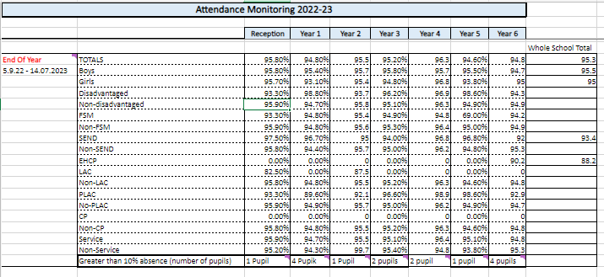

Outcome 6

The development of vocabulary and spoken skills has been a key driver for all areas of the curriculum. Subject leaders and class teachers have developed clear vocabulary progression to support the development of spoken language and the understanding and use of key vocabulary.
All subject leaders identify key vocabulary and have developed learning schemas to support children’s use and understanding of key terms. A focus on developing reading skills for all children, but particularly those in receipt of pupil premium has been a key driver. The synthetics phonics scheme within KS1 has provided online resources to support learning at home and ensure that the reading materials carefully and closely match individual needs. Training for staff has supported the phonics scheme and has ensured that key teaching and learning strategies are used consistently.
Frequent reading opportunities are taken with pupil premium children to ensure the development of key vocabulary.

Outcome 7 music/ enrichment

Pupil premium children in receipt of free school meals are provided with the opportunity to take up a musical instrument.
Music lessons have been provided for brass, piano, guitar, Ukulele. One practical instrumental exam has been paid for.8 children have received instrumental lessons.
Musical enrichment opportunities are provided for all children to inspire and enrich the curriculum. This includes,
Whole class instrument tuition- Violin. Music performances, including African drumming, swing band, piano recitals, vocal/ choral recitals, Wye Valley music chamber orchestra series recitals.
Extra Curricula enrichment.
All children in receipt of Pupil Premium are offered one free club per year. Additional free clubs are offered throughout the year and children with Pupil Premium are encouraged to take these up.
Club attendance
Disadvantaged | FSM | PP including service | non attendance
13 children | 9 children | 17 children | 10
65% | 69% | 65%
 |  |  | 70% attend lunchtime club

Externally provided programmes
Please include the names of any non-DfE programmes that you purchased in the previous academic year. This will help the Department for Education identify which ones are popular in England
Programme | Provider
TrickBox | Trickbox
TT Rockstars
Reading Eggs
Neli speech | Nuffield

Service pupil premium funding (optional)
Measure Details | What was the impact of that spending on
class based and support  External professional support, Educational Psychology  Nurture/ Elsa support provided  Class based and HLTA Interventions | children were able to access class based learning.  Individual learning needs identified and supported  Individual personal and social challenges addressed and supported  individual barriers to learning addressed.

