Tutshill Combined Design and technology, and Art and design scheme
Long term plan

This EYFS: Reception, Key stage 1 and Key stage 2 plan is designed to alternate between teaching Design and technology and Art and Design each half term

long-term plan: A&D and D&T - Overview (Reception -Year 3)

.

 | Autumn term |  | Spring term |  | Summer term |  | Stand- alone lessons
 | Design and technology | Art and design | Design and technology | Art and design | Design and technology | Art and design
EYFS:  Reception | Structures: Junk modelling  (6 lessons) | Drawing: Marvellous marks (6 lessons) | Textiles: Bookmarks (6 lessons) | Painting and mixed media: Paint my world  (6 lessons) | Structures: Boats (6 lessons) | Sculpture and 3D: Creation station (6 lessons) | Design and technology  Unit: Seasonal projects - as and when relevant throughout the year.  Art and design  Seasonal Crafts as and when relevant throughout the year.
Year 1 | Structures: Constructing a windmill  (4 lessons) | Drawing: Make your mark  (5 lessons) | Textiles: Puppets (4 lessons) | Sculpture and 3D:  Paper play (5 lessons) | Cooking and nutrition: Fruit and vegetables  (4 lessons) | Painting and mixed media: Colour splash  (5 lessons)
Year 2 | Art and design | Design and technology | Art and design | Design and technology | Art and design | Design and technology
 | Sculpture and 3D:  Clay houses (5 lessons) | Structures: Baby bear's chair  (4 lessons) | Drawing: Tell a story  (5 lessons) | Mechanisms: Fairground wheel (4 lessons) | Craft and design:  Map it out (5 lessons | Mechanisms: Making a moving monster  (4 lessons)
Year 3 | Design and technology | Art and design | Design and technology | Art and design | Design and technology | Art and design
 | Cooking and nutrition: Eating seasonally  (4 lessons) | Painting and mixed media: Prehistoric painting  (5 lessons) | Digital world: Electronic charm (4 lessons) | Craft and design: Ancient Egyptian scrolls  (5 lessons) | Structures: Constructing a castle  (4 lessons) | Drawing: Growing artists  (5 lessons)

Suggested long-term plan: A&D and D&T - Overview (Year 4-6)

As our units are shorter than six weeks, we have added some suggestions for stand-alone lessons.

 | Autumn term |  | Spring term |  | Summer term |  | Stand alone lessons
 | Art and design | Design and technology | Art and design | Design and technology | Art and design | Design and technology | Sculpture and 3D: Interactive installation  (5 lessons)
Year 4 | Drawing: Power prints  (5 lessons) | Structure: Pavilions (4 lessons) | Painting and mixed media: Light and dark  (5 lessons) | Mechanical systems: Making a slingshot car  (4 lessons) | Sculpture and 3D: Mega materials  (5 lessons) | Electrical systems:  Torches  (4 lessons)
Year 5 | Design and technology | Art and design | Design and technology | Art and design | Design and technology | Art and design
 | Electrical systems:  Doodlers (4 lessons) | Painting and mixed media: Portraits  (5 lessons) | Mechanical systems: Making a pop-up book  (4 lessons) | Drawing: I need space  (5 lessons) | Cooking and nutrition: What could be healthier? (4 lessons) | Craft and design: Architecture  ( 5 lessons)
Year 6 | Art and design | Design and technology | Art and design | Design and technology | Art and design | Design and technology
 | Painting and mixed media: Artist study  (5 lessons) | Textiles: Waistcoats (4 lessons) | Craft and design: Photo opportunity (5 lessons) | Structure: Playgrounds (4 lessons) | Sculpture and 3D: Making memories - (5 lessons) | Digital world: Navigating the world  (4 lessons)

Why have we chosen to include these Art and design units?
Art and design units provide coverage of the national curriculum.

The Art and design units have been given the titles Drawing, Painting and mixed media, Sculpture and 3D and Craft and design to make skills progression within the spiral curriculum more easily identiﬁable. However, it is important to remember that skills in Art and design ﬂow between units; the curriculum has been designed to be holistic.

For example, drawing skills appear in almost every unit; children may apply what they have learned about mixed-media to a task in a Sculpture and 3D unit, and so on. When identifying skills for assessment, it will help to consider skills coverage from across all the units taught within the year group.

Because our Art and design units are designed to take ﬁve lessons, teachers may also have stand alone lessons linked to their curriculum learning, festivals or additional learning linked to the seasons.

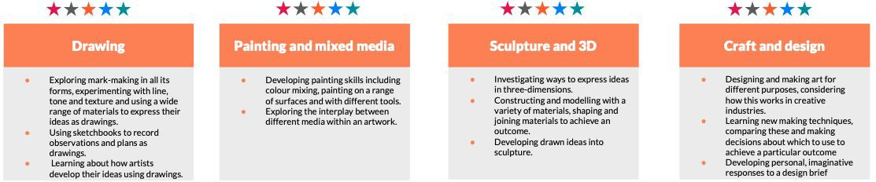

Slong-term plan: A&D - Outline (EYFS: Reception)

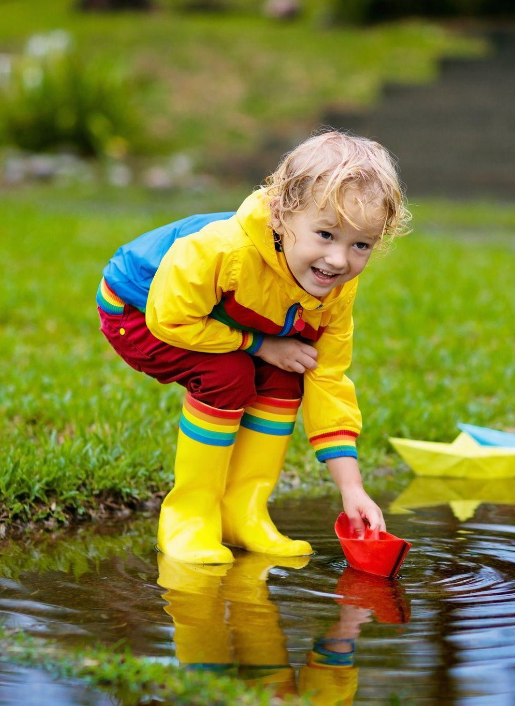
 | Reception
Autumn term | Drawing: Marvellous marks  Exploring mark making and using the language of texture, children use wax crayons to make rubbings and chalk on different surfaces. They use felt tips to explore colour and pencils to create observational drawings of their faces.
Spring term | Painting Paint my world  Creating child-led paintings using ﬁngers and natural items as tools, children learn that colours can be mixed and that paintings can be abstract or ﬁgurative. They make collages and explore different techniques for using paint when creating splatter pictures.
Summer term | Sculpture and 3D: Creation station  Manipulating playdough and clay to make animal sculptures and their own creations, children begin to use language associated with forces: push, pull, twist etc. They create natural landscape pictures using items they have found outdoors.

long-term plan: A&D - Outline (KS1)

 | Year 1 | Year 2
Autumn term | Drawing: Make your mark  Developing observational drawing skills when exploring mark-making . Children use a range of tools, investigating how texture can be created in drawings. They apply their skills to a collaborative piece using music as a stimulus and investigate artists Bridget Riley and Zaria Forman. | Sculpture and 3D: Clay houses  Developing their ability to work with clay, children learn how to create simple thumb pots then explore the work of sculptor Rachel Whiteread and apply her ideas in a ﬁnal piece that uses techniques such as cutting, shaping, joining and impressing into clay.
Spring term | .  Sculpture and 3D: Paper play  Creating simple three dimensional shapes and structures using familiar materials, children develop skills in manipulating paper and card. They fold, roll and scrunch materials to make their own sculpture. There are opportunities to extend learning to make a collaborative sculptural piece based on the art of Louise Bourgeois. | Drawing: Tell a story  Using storybook illustration as a stimulus, children develop their mark-making to explore a wider range of tools and experiment with creating texture to add detail to drawings.
Summer term | Painting and mixed media: Colour splash  Exploring colour mixing through paint play, children use a range of tools and work on different surfaces. They create paintings inspired by Clarice Cliff and Jasper Johns. | Craft and design: Map it out  Responding to a design brief, children create a piece of art that represents their local area using a map as their stimulus. They learn three techniques for working creatively with materials and at the end of the project, evaluate their design ideas, choosing the best to meet the brief.

long-term plan: A&D - Outline (Lower KS2)

 | Year 3 | Year 4
Autumn term | Painting and mixed media: Prehistoric Painting  Discovering how and why our ancient ancestors made art, experimenting with natural materials to make homemade paints and playing with scale to paint on a range of surfaces. | Drawing: Power prints  Using everyday electrical items as a starting point, pupils develop an awareness of composition in drawing and combine media for effect when developing a drawing into a print.
Spring term | Craft and design: Ancient Egyptian scrolls  Learning about the way colour, scale and pattern inﬂuenced ancient Egyptian art, children explore the technique of papermaking to create a papyrus-style scroll. Ideas are extended to create a modern response by designing a ‘zine’. | Painting and mixed media: Light and dark  Developing colour mixing skills, using shades and tints to show form and create three dimensions when painting. Pupils learn about composition and plan their own still life to paint, applying chosen techniques.
Summer term | .  Drawing: Growing artists  Using botanical drawings and scientiﬁc plant studies as inspiration, pupils explore the techniques of artists such as Georgia O’Keefe and Maud Purdy to draw natural forms, becoming aware of differences in the choice of drawing medium, scale and the way tonal shading can help create form. | Sculpture and 3D: Mega Materials:  Exploring how different materials can be shaped and joined and learning about techniques used by artists as diverse as Barbara Hepworth and Sokari Douglas-Camp, children create their own sculptures.

long-term plan: A&D - Outline (Upper KS2)

 | Year 5 | Year 6
Autumn term | Painting and mixed media: Portraits  Investigating self-portraits by a range of artists, children use photographs of themselves as a starting point for developing their own unique self-portraits in mixed-media. | Painting and mixed media: Artist Study  Exploring a selection of paintings through art appreciation activities. Collecting ideas in sketchbooks and planning for a final piece after researching the life, techniques and artistic intentions of an artist that interests them.
Spring term | Drawing: I need space  Developing ideas more independently, pupils consider the purpose of drawings as they investigate how imagery was used in the ‘Space race’ that began in the 1950s. They combine collage and printmaking to create a piece in their own style. | Craft and design: Photo opportunity  Exploring photography as a medium for expressing ideas, pupils investigate scale and composition, colour and techniques for adapting ﬁnished images. They use digital media to design and create photographic imagery for a speciﬁc design brief.
Summer term | Craft and design: Architecture  Investigating the built environment through drawing and printmaking, learning about the work of architect Zaha Hadid, creatively presenting research on artist Hundertwasser and exploring the symbolism of monument design. | Sculpture and 3D: Making memories  Creating a personal memory box using a collection of found objects and hand-sculptured forms, reﬂecting primary school life with symbolic and personal meaning.

Version history

